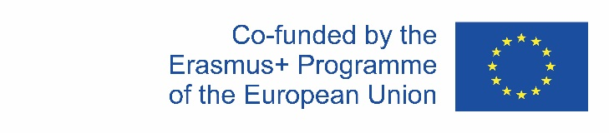

|  |  |  |
| --- | --- | --- |
|  |  |  |

|  |
| --- |
| **Unpacking mathematical concepts**  **in multiple languages** |
| **Examples of triangle, perimeter and even numbers** |

|  |  |
| --- | --- |
| **Cite as** | Uribe, Ángela, Prediger, Susanne, Platen, Yasmin, Ferrari, Eugenia, Lekaus, Silke, Meaney, Tamsin, Revina, Shintia, & Schüler-Meyer, Alexander (2025). Unpacking mathematical concepts in multiple languages: Examples triangle, perimeter and even numbers. Multiple-language-responsive teaching material. German Center for Mathematics Teacher Education. Open Educational Resource under sima.dzlm.de/um/multiple-languages and multilingualmath.nl |
| **Project affiliation** | The teaching material was developed and investigated in the project **ML2** – Exploiting the Power of Multiple Languages for Mathematics Learning which was funded by Erasmus+ Programme (EU-Grant Nr. 2021-1-NL01-KA220-SCH-000024585, grant to Alexander Schüler-Meyer (lead), Tamsin Meaney and Susanne Prediger). |
| **Links and reference to other materials** | Two films for teachers explain the mathematics education background of the material under sima.dzlm.de/um/multiple-languages |
|  | The teacher professional development material can be used under the Creative Commons License 4.0 International BY-SA (Attribution – Share Alike). Photos have different licences. |

## Background of the teaching material for teachers

2-page Teacher Manual

Dear mathematics teachers,

With this teaching material, we aim to give an idea of how you can use multiple languages in your mathematics classrooms. We can demonstrate our appreciation of language diversity by valuing the linguistic diversity the students bring and permitting the use of multiple languages in pair and group work. This can empower students to engage in more intense communication, which is important at a general education level. Encouraging communication in multiple languages supports students in building bridges from everyday life into mathematics and back.

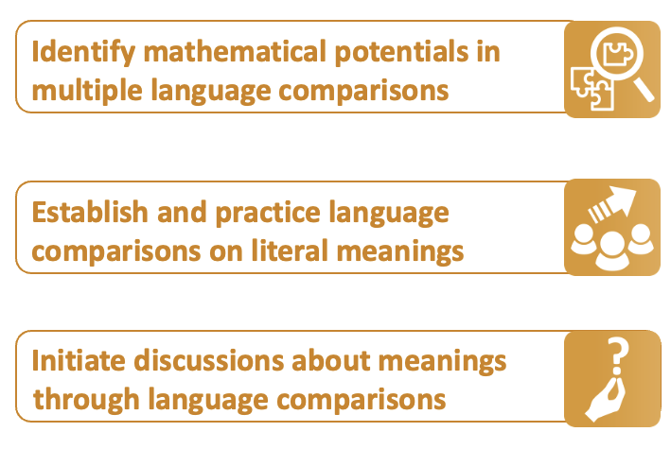Nevertheless, beyond these pedagogical and communicative purposes, we can also exploit the power of multiple languages for *mathematics learning* itself, i.e., for epistemic purposes. Our approach is to identify mathematical potentials, establish and develop language comparisons of the literal meanings of terms and then initiate discussions about meanings through language comparisons.

We have produced two films for teachers (sima.dzlm.de/um/multiple-languages) that explain the mathematics education background of this material under sima.dzlm.de/um/multiple-languages. These films also contain scenes from mathematics classrooms showing the idea: When students break down terms for mathematical concepts from other languages into their literal meanings, then, different aspects of meaning can sometimes emerge. When this happens a more multifaceted view of the whole concept becomes available than if the concept is discussed in only one language. This can encourage students to explain the meanings of concepts in the first place, and to connect several meanings to each other. Consequently, the language comparisons provide great opportunities to initiate thinking and talking about mathematics by unpacking terms from multiple languages.

To do this, however, we first need to introduce students to the idea of translating not just by overall sense, but literally. This makes language reflection possible. Later, we can build on this by eliciting further technical terms and their literal translations from multilingual students. This positions these students as knowers and valuable contributors to classroom discussions.

The teaching material contains reflections on three mathematical concepts:

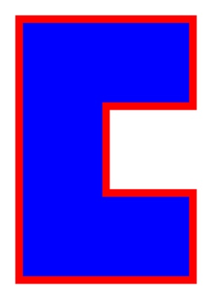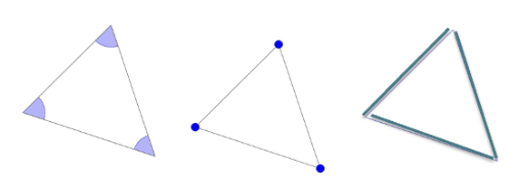

* The concept of **Triangle** is used to introduce the practice of language comparison in a conceptually simple case: **Tri-ángulo** (Spanisch for “three-angle”)**,   
  Drei-eck** (German for “three-vertex”), **Tre-kant** (Danish for “three-side”); each refers to different components of the triangle. By discussing differences, students become aware that unpacking words can be mathematically interesting.
* 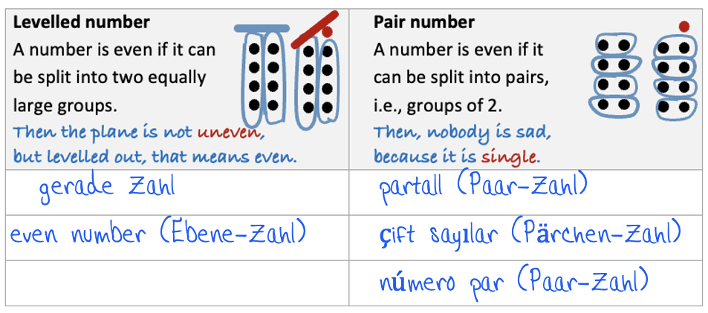**Area and perimeter** provide the second example, and focuses on conceptually challenging students to clearly distinguish between them. **Omtrek** (Netherlands for “around-track”) speaks nicely and is easy to distinguish from **Emvadón** (Greek “go into something“).
* **Odd and even** is the third example: The different terms for odd and even in multiple languages refer to two models of division: **gerade Zahl** (German for “levelled-out number”) uses the idea of partitive division, while **çift sayılar** (Turkish for “couple number”) refers to quotitive division.

Even when the area/perimeter or odd/even are taught separately, we suggest to start with the triangle example to sensitze students for language reflections on literal meanings.

**Suggestion for a possible lesson plan** (planned for 135 min + 30 min homework)  
(Lesson plan to be flexibly adapted according to the needs of each class)

2-page Teacher Manual

|  |  |  |  |  |  |
| --- | --- | --- | --- | --- | --- |
| Task | | Activity setting | Learning goal and steps to the learning goal | | Time |
| 1 |  | | Triangle – Dreieck – Trekant | | 20 min |
|  |  | | **Introduce students to language comparison practices by unpacking literal meanings** | |  |
| **a) b)** | Plenary Plenary | | * Brief question for unpacking first word: triangle * Explain expectation for task b) (not the solution) | | 3 min |
|  | Pairs | | * Briefly match terms Triangle – Dreieck – Trekant to three figures that  emphasize different components (students intuitively search for meanings) | | 3 min |
|  | Plenary | | * Justify the matches and explain how to unpack meanings: How have you decided  what to compare? (students are introduced to unpacking literal meanings) | | 4 min |
| **c)** | Individual | | * Write down explanations (students consolidate what was discussed before) | | 3 min |
| **d)** | Individual Plenary | | * Individual search for other languages (use google translate) * Briefly exchange further examples (teachers monitor whether translations provided overall sense or were literal) | | 4 min  3 min |
| **2** |  | | **Perimeter and area: Distinguishing concepts by unpacking terms** | **25+20 min** | |
| **a)** | Individual | | * Remember what area and perimeter are by calculating an example | | 3 min |
| **b)** | Individual | | * Write down explanation for difference between perimeter and area | | 2 min |
|  | Plenary | | * Students present two or three explanations | | 4 min |
| **c)** | Plenary | | * Unpack “Omtrek” (introduce practice of unpacking) | | 3 min |
| **de)** | Pairs | | * Unpack terms from multiple languages and explain the assumed meanings | | 5 min |
|  | Plenary | | * Students present their explanations | | 8 min |
| *If you have only one 45-minute lesson, a cut can be here to continue with 2f) in the next lesson.* | | | | | |
| **f)** | Plenary | | * Briefly discuss German mnemonic bridge – prepositions in all the words | | 2 min |
| **g)** | Plenary | | * Explain expectation for task g) (not the solution) | | 1 min |
|  | Pairs | | * Write questions for perimeter and area for different situations | | 10 min |
|  | Plenary | | * Brief exchange for written questions (teacher monitors whether all students now distinguish area and perimeter correctly) | | 5 min |
|  | Input | | * Teacher summarizes, e.g.: “Sometimes, terms in other languages are great to unpack the meaning of a mathematical concepts. Other languages might speak to us better than the official language of instruction. Make use of this in the future!” | | 2 min |
| **3** |  | | **Odd / even numbers – Part 1: Mobilize students own ideas on odd and even** | | **25 min** |
| **ab)** | Individual | | * Draw an image, what is an odd number? What could a “single number” mean? | | 8 min |
|  | Plenary | | * Exchange ideas from a) and b) | | 8 min |
| **c)** | Plenary | | * If the students did not have a good idea for a diagram in a) where to describe “levelled out”, continue with 4a) in which the dot diagram is introduced | | 9 min |
| **4** |  | | **Odd / even numbers – Part 2: Understand division in two models by unpacking terms** | | 20 min |
| **ab)** | Pairs | | * Draw and discuss diagrams for odd and even, include a levelled-out bar and an uneven bar, make sense of a “couple number” | | 10 min |
|  | Plenary | | * Exchange ideas and explanations | | 10 min |
| **5** |  | | **Odd / even numbers – Part 3: Systematize terms for two models of division** | | 25 min |
| **a-c)** | Pairs | | * Assign terms to two models of division: “levelled number” (partitive division in two equal groups) vs. “pair number “quotitive division into groups of two) | | 8 min |
|  | Plenary | | * Exchange ideas | | 8 min |
|  | Individual | | * Write down individual learning gain | | 5 min |
|  | Plenary | | * Make a brief concluding meta-reflection on the approach of unpacking mathematical concepts in multiple languages. | | 2 min |
| **6** | Homework | | **Odd / even numbers – Part 4: Sum of two numbers** | | 30 min |

Dear students and teachers,

There is power in words, and languages sometimes have different powers!

Let's think about this today, using three examples.

We will unpack terms for mathematical concepts in multiple languages

and see that they can have slightly different meanings.

Sometimes other languages have terms that explain concepts particularly well.

So it's worth taking a closer look.

This allows you to think about the concepts from several perspectives.

Why not give it a try!

Ángela Uribe, Susanne Prediger and Yasemin Platen (Dortmund)

Eugenia Ferrari, Silke Lekaus and Tamsin Meaney (Bergen, Norwegen)

Alexander Schüler-Meyer and Shintia Revina (Eindhoven, Niederlande)

|  |  |  |  |  |
| --- | --- | --- | --- | --- |
| 1 | How to speak about triangles? | | | |
|  | a) | What does the term **triangle** mean literally?  Do you think the name is suitable? Why or why not? | | |
|  | b) | In German, a triangle is called **Dreiec**k (literally: three-vertices), and in Danish **trekant**. What could **tre**, **kant** mean, what do you think? And **triángulo** in Spanish?  Which figure best visualizes the meaning of each of the terms?  Connect each term to the figure that emphasizes the important part. | | |
|  |  | Danish  Trekant | Triángulo | Dreieck  German |
|  |  |  | Spanish |  |
|  |  | **Figure A** | **Figure B** | **Figure C** |
|  | c) | Explain in writing what the three terms have to do  with each other. Do they show the same figure?  Tre-kant  Tri-ángulo  Drei-eck  Why do you think that? | | |
|  |  |  | | |
|  |  |  | | |
|  | d) | Find out what the triangle is called in other languages.  Try to translate these terms literally into your languages.  Do you think the name is appropriate? Why do you think that? | | |

|  |  |  |
| --- | --- | --- |
| 2 | Perimeter and area | |
|  | a) | Determine the perimeter and the area of this figure. |
|  | b) | Some students mix up area and perimeter.  How could you explain the difference? |
|  |  |  |
|  |  |  |
|  | c) | In Dutch, they use the term **Omtrek**.  Do you think this word means **area** or **perimeter**?  Why do you think that? |
|  | d) | When you translate words from other languages literally,  you can discover exciting things. Which terms stand for **perimeter**? Which for **area**?  Do you know any other words for these terms from other languages?  площадь = **Plo**shchad KelilingLuas (Indonesian   for “walk around“)  (Russian for “place“)  (Other languages?)  (Ancient Greek for  “measure around“)  (Greek for  “go into something“) Perimeter (Indonesian   for “extended“)  (Spanish for “zone“) ÁreaΕμβαδόν = Emvadón (Javanese for “step on it“)   Ambah |
|  | e) | Choose a term from d) that you think stands for **perimeter**. Explain why you think this.  Choose a word from d) that you think stands for **area**. Explain why you think this. |
|  |  |  |

|  |  |  |
| --- | --- | --- |
|  | f) | A German textbook offers the following help for memorizing:  **Umfang** contains **Um** (“around”) and **Flächeninhalt** contains **In.**  Can you find something similar insights in the terms in your language?  C:\Users\hafiz\AppData\Local\Microsoft\Windows\INetCache\Content.Word\Umfang_2.jpg |
|  |  |  |
|  | g) **Situation E:**  Horse pasture  **Situation D:**  Swimming pool  **Situation F:** Monastery courtyard and monastery tour  **Situation B:**  Sandpit  **Situation C:**  Stadium  **Situation A:**  Window | In some situations, we are interested in the perimeter, in other situations in the area, sometimes in both.   * Lisa has written a question for Situation A. Does she ask for the perimeter or the area?   Question for Situation A:  Cold wind comes in through the window frames, so Auntie Emma buys insulating tape. How many meters of tape does she need?   * For which situation can you ask a question about the perimeter? * For which situation can you ask about area? |

**Sources of photos on this page (partially not part of the CC-BY-SA license)**

Windows: <https://www.needpix.com/photo/1726535/window-window-frames-wooden-windows-lattice-windows-old-building-free-pictures-free-photos-free-images-royalty-free>

Sand pit: <https://pixabay.com/de/photos/spielplatz-sandkasten-rutsche-wippe-250782/>

Stadium: [https://pixabay.com/de/photos/stadion-fußball-rasen-sport-189777/](https://pixabay.com/de/photos/stadion-fu%C3%9Fball-rasen-sport-189777/)

Swimming pool: <https://pxhere.com/de/photo/635730>

Horse pasture: AI-generated by DALL-E. School-related, personal and commercial use allowed.

Monastry: <https://pixabay.com/de/photos/kirche-buchsbaum-glauben-heilige-1331210/>

|  |  |  |
| --- | --- | --- |
| 3 | Odd and even numbers | |
|  | a) | What is an odd number?   * Explain in your words and draw an image to explain it. * How does the image show that the number is odd? |
|  |  |  |
|  |  |  |
|  | b) | **Odd** numbers, are called أرقام  فردية in Arabic, which literally means **“Single number“**.   * Explain what could be meant with **single number**. |
|  |  |  |
|  |  |  |
|  | c) | In German, they use gerade Zahl, literally, this means “levelled out number**“**.   * Do you think this term is for odd or even numbers? Why do you think that? * Can you see the levelled out amounts in your image from a)? * The other German word is **ungerade**, what do you think that means? |

|  |  |  |
| --- | --- | --- |
| 4 | Odd and even numbers – Part 2 | |
|  | a) | Kenan has drawn this image for the number 9.   * How does this image show that 9 is odd? * Draw similar images for the numbers 4 and 5. * How can you see that they are **gerade / ungerade**? * Can you use this to explain what **gerade / ungerade** and the English term **even** mean? |
|  |  |  |
|  |  |  |
|  | b) | In Turkish, even numbers are called **çift sayılar**,  which literally means **”couple number”.**   * Explain what **couples** have to do with even numbers. * Can you draw another dot image similar to Kenan’s,  for **couple numbers**? * What is different to Kenan’s image in **a)**? |

**Sources of photo on this page (partially not part of the CC-BY-SA license)**

Dancing pairs: [https://de.freepik.com/vektoren-kostenlos/leute-tanzen\_4012052.htm#fromView=keyword&page=3&position=50&uuid=2b1ab5d5-178c-4a7b-bc14-cc06b75c3e6e](https://de.freepik.com/vektoren-kostenlos/leute-tanzen_4012052.htm" \l "fromView=keyword&page=3&position=50&uuid=2b1ab5d5-178c-4a7b-bc14-cc06b75c3e6e)

|  |  |  |  |  |
| --- | --- | --- | --- | --- |
| 5 | Odd and even numbers – Part 3 | | | |
|  |  | In mathematics, even numbers are defined as those which can be divided by 2  without any remainders. This technical definition is the same in all countries. But how we understand and visualize divisibility by 2, this differs in different languages: | | |
|  |  | Levelled number A number is even if it can  be split into two equally  large groups.  Then the bar is not uneven,  but levelled out, that means it is even. |  | Pair number A number is even if it  can be split into pairs,  i.e., groups of 2.  Then, there is no sad  single unit. |
|  |  |  |  |  |
|  |  |  |  |  |
|  |  |  |  |  |
|  |  |  |  |  |
|  | a) | Explain again the difference between **levelled numbers** and **pair numbers**.  Which description do you prefer? | | |
| partall (Norwegian for “pair number“) gerade Zahl (German for  “levelled out”) even number (English for   “levelled out “) çift sayılar (Turkish for  “couple number”) número par (Spanish for “number pair“)  (Other languages?) | b) | Fill in the terms from different languages into the right columns.  Which goes better with the **levelled number**, which better with the **pair number**?  Which further terms do you know or can you find in a dictionary? | | |
|  |  |  | | |

|  |  |  |
| --- | --- | --- |
|  |  |  |
|  | c ) **Situation B:**   Couples dance | Which situation matches better with the levelled number / the pair number,  which one to both?  Ein Bild, das Mobiliar, Im Haus, Szene, Zimmer enthält.  Automatisch generierte Beschreibung  **Situation C:**  Chess competition    **Situation D:**  Cable car  **Situation A:**  Bridge with  building bricks |

|  |  |  |
| --- | --- | --- |
|  | d) | What did you learn about even and odd numbers today?  What did you learn about how multiple languages and words can help you understand mathematics? |
|  |  |  |

**Sources of photos on this page (partially not part of the CC-BY-SA license)**

Bridge: Self-produced

Dancing pairs: <https://de.freepik.com/vektoren-kostenlos/leute-tanzen_4012052.htm#fromView=keyword&page=3&position=50&uuid=2b1ab5d5-178c-4a7b-bc14-cc06b75c3e6e>

Chess competition: AI-generated by DALL-E. School-related, personal and commercial use allowed.

Cable car: <https://de.freepik.com/fotos-kostenlos/vertikales-bild-von-seilbahnen-auf-einem-bergpark_12651421.htm#fromView=keyword&page=1&position=4&uuid=ab02d566-695f-4d82-b11c-d9536bd9caa1>

|  |  |  |
| --- | --- | --- |
| 6 | Odd and even numbers – Part 4: Sum of odd number | |
|  | a) | When you take the sum of two odd numbers: What will you get? Even or odd? Why? |
|  | b) | Below you can see the explanation of an Albanian-speaking student, Tarik.   * Can you explain what Tarik was drawing?  Which parts of the argument can you understand without knowing Albanian? * Tip: The Albanian word çift means pair, as in Turkish. |
|  |  |  |
|  |  |  |
|  |  |  |
|  | c) | Tarik has argued for 5 + 7. Can you generalize the argument for other odd numbers? And to any odd numbers, no matter which two numbers you choose? |
|  |  |  |
|  | d) | Based on Tarik’s drawings and the Arabic idea of describing odd numbers as single numbers, write a text in one of your languages that explains why the sum of two odd numbers is always an even number, no matter which two odd numbers you choose. |

**Scan on this page not part of the CC-BY-SA license**